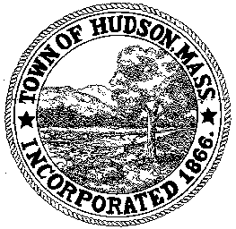

CONSERVATION COMMISSION
78 Main Street, Hudson, MA 01749
(978) 562-2020

Paul Byrne, Chairman W. Minot Wood, Vice Chairman David Esteves, Member

Terrence Joyce, Member Leif Longtine, Member Joseph Rodrigues, Member Al Tashian, Member

Meeting Agenda
June 16, 2011 7:00 P.M.

- Preliminaries
  - Open Meeting
  - Roll Call

2.0 New Business
2.1 DEP 190-0558
Location: 201 Manning Street
Applicant: Town of Hudson
Project Description: Construction of a new school building, and associated parking, walkways, athletic fields, and utilities

2.2 190-0451 Request for Certificate of Compliance
Location: 20 Eaton Drive

2.3 Ratify Enforcement Order – Palmieri Drive

2.4 Request for Review and Comments
201 Manning Street

2.4 Minutes May 19, 2011

2.5 Voucher ConCom 061611 $4150.00

2.6 Summer Schedule

3.0 Old Business
3.1 Schedule meeting for Otsego Drive

4.0 Correspondence
4.1 Tennessee Gas Pipeline VMP approval

5.0 Adjournment:

Next Meeting: July 7, 2011

